# Experiment # 3

Verification of Ohm’s Law using PSPICE Simulation

# Objective:

To verify ohm’s law on electric circuit simulation tool like PSPICE

# Ohm’s Law:

**Ohm's law** states that the [current](https://en.wikipedia.org/wiki/Electric_current) through a [conductor](https://en.wikipedia.org/wiki/Electrical_conductor) between two points is directly [proportional](https://en.wikipedia.org/wiki/Proportionality_(mathematics)) to the [voltage](https://en.wikipedia.org/wiki/Voltage) across the two points. Introducing the constant of proportionality, the [resistance](https://en.wikipedia.org/wiki/Electrical_resistance), one arrives at the usual mathematical equation that describes this relationship:

{\displaystyle I={\frac {V}{R}},} 

where *I* is the current through the conductor in units of [amperes](https://en.wikipedia.org/wiki/Ampere), *V* is the voltage measured *across* the conductor in units of [volts](https://en.wikipedia.org/wiki/Volt), and *R* is the [resistance](https://en.wikipedia.org/wiki/Electrical_resistance) of the conductor in units of [ohms](https://en.wikipedia.org/wiki/Ohm).

Circuit Diagram:

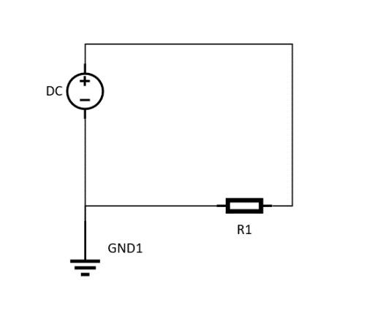

# PSPICE:

PSPICE is a circuit analysis tool that allows the user to simulate a circuit and extract key voltages and currents. Information is entered into PSPICE via one of two methods; they are a typed 'Net List' or by designing a visual a schematic which is transformed into a netlist.

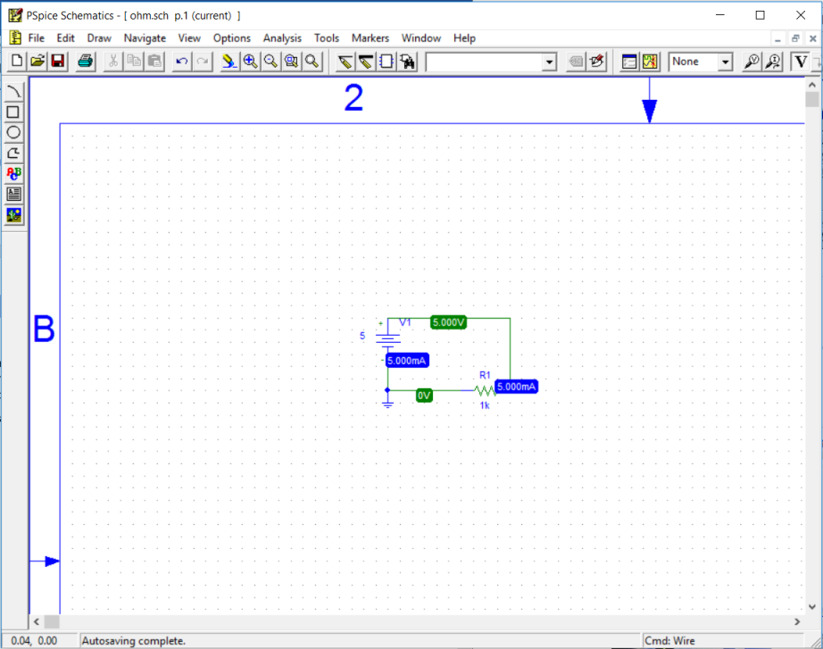

Figure 8 PSPICE

We can verify ohm’s law using PSPICE.

# Procedure:

1. Open PSPICE schematics.
2. Click on the “Get new part” button in the tool bar.
3. Type “r” and click “Place” button then toggle your mouse to the position where you want to place the resistor in your circuit.
4. Type “VDC” and click “Place” button then toggle your mouse to the position where you want to place the battery in your circuit.
5. Type “GND_EARTH” and click “Place” button then toggle your mouse to the position where you want to place the ground outlet in your circuit.
6. Now connect the components using the “Draw wire” tool from the tool bar.
7. Click the “Simulate” button from the tool to simulate your circuit.
8. Click the “Enable bias voltage display” and “Enable bias current display” buttons from the tool bar to take the readings from the circuit.

# Observation:

**R = 1k Ω**

|  |  |  |
| --- | --- | --- |
| **Serial Number** | **Voltage (v)** | **Current (A)** |
| 1. | 5 |  |
| 2. | 10 |  |
| 3. | 15 |  |
| 4. | 20 |  |
| 5. | 25 |  |
| 6. | 30 |  |